COLLECTION OF IECEx / ExTAG DECISIONS

Standard:  IEC 60079-1: 2007 (Ed 6)  IEC 60079-1: 2003 (Ed 5) | Clauses:  3.10, 15.1.2.3
Subject:  Measurement of Pressure Rise Time in relation to determination if Pressure Piling has occurred  Status of document: Approved | Key words:  - Pressure Measurement  - Pressure Rise Time  - Pressure Piling | Date: 2009.11.16  Originator of proposal:  Baseefa  TC/SC involved: 31
Introduction

This Decision Sheet applies to all flameproof equipment.
Question

How is rise time to be determined”?
Answer

Rise time is to be determined taking into account the following figure which was published in earlier editions of IEC 79-1 and has been reinstated by MT 60079-1 in the current draft for the next edition of IEC 60079-1.
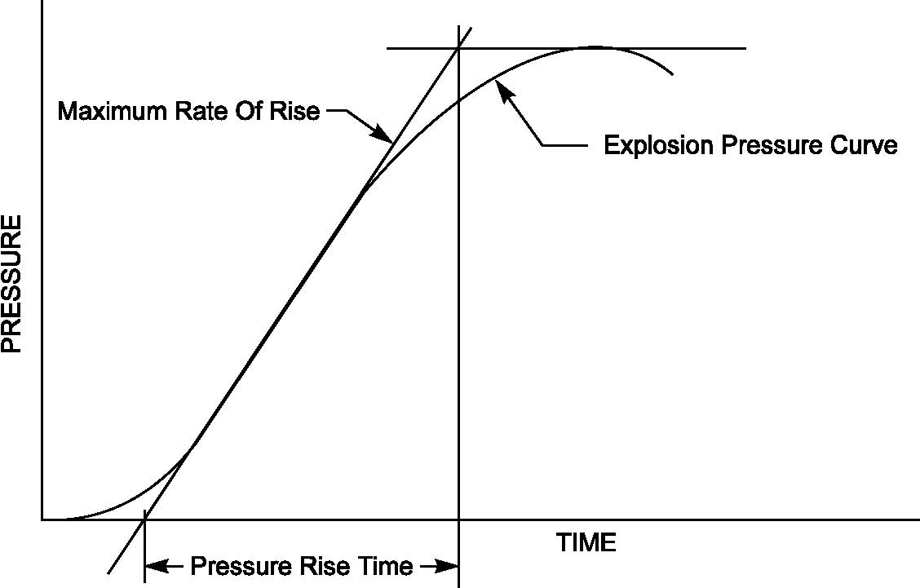
Figure 23 – Pressure rise time

Additional Information

This figure is also currently published in some national implementations of IEC 60079-1.

When pressure piling occurs as a result of compartmentalisation of the flameproof enclosure, the pressure curve in the compartment remote from the ignition source will usually show an initial gradual rise of pressure. This is as a result of the pre-pressurisation of the compartment, before the rapid increase in pressure as ignition of the pre-pressurised mixture occurs. It is important that the pre-pressurisation is not confused with the actual explosion. The shape of the initial slope will depend greatly on the individual physical layout and the relative positions of ignition source and pressure sensors.

The determination of rise time based on the maximum rate of rise is intended to ensure, as far as possible, a common interpretation by all testing laboratories.
The maximum rate of rise may be determined, for example by computer software, by measuring the slope between the points at 10% and 90% of the peak explosion pressure
measurement, or by other suitable means such that the pressure rise time is not affected, by a slower rate of pressure rise at the start and finish of the measurement. However it is recommended that the actual curve is reviewed by a competent person to confirm that any particular automated measurement system has selected a reasonable interpretation of “maximum rate of rise”.

MT 60079-1 is asked to consider the issue of an ISH for editions 5 and 6 of the standard.

