INTERNATIONAL ELECTROTECHNICAL COMMISSION SYSTEM FOR ERTIFICATION TO STANDARDS RELATING TO EQUIPMENT FOR USE IN EXPLOSIVE ATMOSPHERES (IECEx SYSTEM)

TITLE: IECEx Assessment Report for the acceptance of National Quality Supervision & Inspection Center of Hoisting and Metallurgical & Explosion-proof Electric Machine (CHEM) as an IECEx Test Laboratory (ExTL) within the IECEx System.

Circulated to: Ex Management Committee, ExMC

INTRODUCTION

This document contains the IECEx Assessment Report for the acceptance of National Quality Supervision & Inspection Center of Hoisting and Metallurgical & Explosion-proof Electric Machine (CHEM) as an IECEx Test Laboratory (ExTL) within the IECEx System.

Please consider this assessment report and return the completed voting form,
to the IECEx Secretariat by- 120928

Your speedy response to the voting process will be very much appreciated.

Chris Agius
IECEx Secretariat

IECEx Secretariat  Standards Australia Building  286 Sussex Street  Sydney NSW 2000  Australia | Tel: +61 2 8206 6940  Fax: +61 2 8206 6272  Email: chris.agius@iecex.com
IECEx ASSESSMENT REPORT FOR the National Quality Supervision & Inspection Center of Hoisting and Metallurgical & Explosion-proof Electric Machine (CHEM), Jiamusi, P.R. of China

(IECEx TEST LABORATORY)

Type of Assessment: (please mark)

Initial assessment for Candidate ExTL X

Re-Assessment of ExTL

Scope Extension of ExTL

- OBJECT AND FIELD OF APPLICATION

  - Country:

P.R. of China

  - Name of ExTL

National Quality Supervision & Inspection Center of Hoisting and Metallurgical & Explosion-proof Electric Machine (CHEM)

  - Members of the Assessment Team

Heinz Berger – IECEx Officer - IECEx Lead Assessor
Ajay Maira – IECEx Expert Assessor

  - Place and Date of Assessment

CHEM
3 Anqing Street
Jiamusi
154005 Heilongjiang Province
P.R. of China

June 27th – 29th, 2012

  - Assessment References

- IECEx 02 Equipment Scheme Rules (current version)
- IECEx OD 003 - 2 Assessment, surveillance assessment and re-assessment of ExCBs and ExTLs operating in the IECEx 02, IECEx Certified Equipment Scheme (current version)
- IECEx OD 005-1, -2 and -3; Manufacturer Assessment (current version)
- IEC 80079-34 Explosive atmospheres - Part 34: Application of quality systems for equipment manufactures
- IECEx OD 009 Equipment Scheme Procedures (current version)
- IECEx OD 18 Checklist 17025(current version)
- IECEx OD 24 Witness Testing/manufacturer and users Facility
- ISO/IEC 17025:2005
- IECEx Technical Guidance Documents (TGDs)
- ExTAG decision sheets (DSs)
- OD's related to technical issues (if applicable)

  - Scope of Application

Number | Title | Acceptance
60079-0  Edition 5  Edition 6 | Explosive atmospheres -  Part 0: Equipment - General requirements | YES
60079-1  Edition 5  Edition 6 | Explosive atmospheres -  Part 1: Equipment protection by flameproof enclosures 'd' | YES
60079-2  Edition 4  Edition 5 | Explosive atmospheres -  Part 2: Equipment protection by pressurized enclosures 'p' | YES
60079-7  Edition 3  Edition 4 | Explosive atmospheres -  Part 7: Equipment protection by increased safety 'e' | YES
60079-11  Edition 5  Edition 6 | Explosive atmospheres -  Part 11: Equipment protection by intrinsic safety 'i' | YES
60079-31  Edition 1 | Explosive atmospheres -  Part 31: Equipment dust ignition protection by enclosure "t" | YES
61241-0  Edition 1 | Electrical apparatus for use in the presence of combustible dust -  Part 0: General requirements | YES
61241-1  Edition 1 | Electrical apparatus for use in the presence of combustible dust -  Part 1: Protection by enclosures 'tD' | YES

  - Candidate TL Persons Interviewed

Name | Position
Shang Zhikui | Director of CHEM
Wang Weiyue | Vice director of CHEM
Zhang Guoyan | Vice director of CHEM
Yin Hong | Interpreter (PCEC)
Xin Yi | Interpreter
Wang Min | Interpreter
Zeng Xin | Interpreter
Li Hede | Cert. Dept. Technical Consultant CQM
Deng Qiuwei | Engineer CQM
Yang Xichun | Manager of Testing Lab
Song Zhifang | Manager of Testing Lab
Li Jigui | Manager of Testing Lab
Zhang Pingyi | Test Engineer
Liu Yongqin | Test Engineer
Li Hongyou | Test Engineer
Guo Jiamin | Test Engineer
Li Jiansheng | Test Engineer
Sun Lei | Test Engineer
Yin Fajun | Test Engineer

  - Legal Entity of The Candidate TL

Jiamusi Explosion-Proof Electric Machine Institute (JEXM)

JEXM where CHEM belongs to holds a business license from the "Qianjin Branch of Municipal Administration for Industry and Commerce of Jiamusi with the number 230804100001382. The license was issued on December 4th, 1991 and is valid until December 4th, 2013.

  - Associated ExCB

China Quality Mark Certification Group Co. Ltd. (CQM) in Beijing. The contract between CQM and CHEM was last updated on July 25th, 2012 and is valid until July 24th, 2015. IECEx working procedure No. CX-C30-2010 describes the operation between CQM and CHEM. In this procedure a "Catalog list of Interface File for CHEM and CQM" steers the operations. The documents were presented during the assessment and found to meet the requirements of the IECEx.

1.10 Financial Support

The operation is completely self-founded by the income from testing.

1.11 History

In 1992 CHEM was established under the authorization of State Bureau of Technical Supervision. The detection range covers various kinds of performance tests for explosion-proof electric apparatuses, etcetera. The history of explosion-proof performance test can be traced back to the year of 1962. JEXM was the first organization in the P.R. of China issuing a certificate for explosion-proof electric machine for use in a factory (Group II).

- ORGANISATION

  - Names, Titles and Experience of the Senior Executives

Name | Title | Experience
Shang Zhikui | Director of CHEM | 25 years for Ex testing, 2 years for vice manager of CHEM, 5 years for vice director of JEXM, from December 2008 he is director of JEXM and CHEM.
Wang Weiyue | Vice director of CHEM | 20 years for Ex testing, 3 years for design and inspection of Ex apparatus  8 years for managing Ex testing in CHEM
Zhang Guoyan | Vice director of CHEM | 23 years of Ex testing, 4 years for vice manager of explosion-proof test lab, 4 years for manager of explosion-proof test lab, from June 2006 he is vice director of CHEM.
Zhang Liyuan | Vice director of CHEM | 23 years for Ex testing, 8 years for engineer of CHEM, 19 years manager of CHEM, 23 years for inspection work of fans, pumps, and motors.

  - Name, Title and Experience of the Quality Management Representative

Name | Title | Experience in Ex
Wang Weiyue | Vice director of CHEM | 20 years for Ex testing, 3 years for design and inspection of Ex apparatus  8 years for managing Ex testing in CHEM

  - Name and Title of Nominated Principal Contact

Name | Title | Comments
Wang Weiyue | Vice director of CHEM | E-Mail: wwy6341@126.com

  - Employees

Name | Title | Experience in Ex
Yang Xichun | Manager of Testing Lab | 8 years
Song Zhifang | Manager of Testing Lab | 20 years
Li Jigui | Manager of Testing Lab | 10 years
Wang Fangli | Manager of Testing Lab | 10 years
Zhang Pingyi | Test Engineer | 25 years
Liu Yongqin | Test Engineer | 20 years
Li Hongyou | Test Engineer | 8 years
Guo Jiamin | Test Engineer | 16 years
Li Jiansheng | Test Engineer | 15 years
Sun Lei | Test Engineer | 6 years
Yin Fajun | Test Engineer | 8 years

  - Organizational Structure

See ANNEXES 1, 2 and 3 for the organization.

- RESOURCES

14 persons are involved in IECEx activities in the testing area. The building area of the lab is 4420m², testing area is 2960m².

- DOCUMENTATION

  - Quality Manual

The quality manual of CHEM has the number JexTL-SC_05/2010. It consist of several levels: SC (General), CX (Procedures), JG & CG (test and equipment instructions) and L (Forms, Records/Reports).
The QM, following ISO 17025, was reviewed during the assessment and found to meet the requirements of the IECEx.

  - Procedures

Procedures are described in the CX part of the QM. Procedure CX-C30-2010 deals with IECEx activities and the cooperation with CQM as the ExCB. This procedure was checked in detail and found to meet the requirements of the IECEx.

  - Work Instructions

Under the designation JG and CG there are a large number of test and equipment instructions (presently 93). As an example, instruction JG058-2011 deals with the specification for light aging tests and CG028-2011 deals with the operation specification for oxygen analyzer. Some of the JGs and CGs were checked during the assessment and found to meet the requirements of the IECEx.

  - Records

Procedure CX-C10-2010 deals with the control of records. The procedure was checked and found to meet the requirements of the IECEx.

  - Document Change Control

Document control is described in chapter 4.3 of the QM as well in procedures CX-C02-2010 (for documents in paper) and CX-C24-2010 (for documents in electronic format). This was checked during the assessment and found to meet the requirements of the IECEx.

  - Test Records

This issue is described in chapter 5.10 of the QM and in procedure CX-C22-2010. The documents were checked during the assessment and found to meet the requirements of the IECEx.

- TEST REPORTS

  - Test Reports Issued

Number of test reports issued under national or regional schemes in the preceding four years for each type of protection:

Standards | Title | Number of issued test report
 |  | 2008 | 2009 | 2010 | 2011/12 | Total
60079-0 | Explosive atmospheres -  Part 0: Equipment - General requirements | --- | --- | --- | --- | Part 0 included in numbers below
60079-1 | Explosive atmospheres -  Part 1: Equipment protection by flameproof enclosures 'd' | 419  (GB) | 287  (GB) | 509  (GB) | 984  (GB)  4(IEC) | 2199
60079-2 | Explosive atmospheres -  Part 2: Equipment protection by pressurized enclosures 'p' | 1  (GB) | 2  (GB) | --- | 5  (GB) | 8
60079-7 | Explosive atmospheres -  Part 7: Equipment protection by increased safety 'e' | --- | 64  (GB) | 95  (GB) | 143  (GB) | 302
60079-11 | Explosive atmospheres -  Part 11: Equipment protection by intrinsic safety 'i' | 43  (GB) | 51  (GB) | 41  (GB) | 70  (GB) | 205
60079-31 | Explosive atmospheres -  Part 31: Equipment dust ignition protection by enclosure "t" | --- | --- | --- | ---
61241-0 | Electrical apparatus for use in the presence of combustible dust -  Part 0: General requirements | --- | --- | --- | --- | Part 0 included in numbers below
61241-1 | Electrical apparatus for use in the presence of combustible dust -  Part 1: Protection by enclosures 'tD' | 7  (GB) | 43  (GB) | 9  (GB) | 211  (GB) | 270

- CALIBRATION

Calibration is described in procedure CX-C17-2010. The list of equipment is controlled by a person responsible for calibration, also in charge of recalibration activities. Several calibration certificates were checked and found to meet the requirements of the IECEx.

- CONFIDENTIALITY

Procedure CX-C01-2010 deals with confidentiality. Each member of staff signs a confidentiality agreement. The signed agreements were checked and found to be complete.

- NATIONAL ACCREDITATION

CHEM holds an accreditation from CNAS under the registration number L0484, with the scope covering standards listed in Clause 1.6. The certificate was issued on May 3rd, 2011 and is valid until May 2nd, 2014. The last update was made on July 10th, 2012 after CNAS Re-Assessment. The scope is covering all standards applied for. See ANNEX 4 for the certificate.

- RECOGNITION AND AGREEMENTS

CHEM has signed agreements, in addition to the signed agreement with CQM as ExCB, on mutual acceptance of the test results with two international certification bodies. SIRA (UK) and BOCTHNN (Russia)

- INTERNAL AUDIT AND PERIODIC REVIEW

Internal audits are described in chapter 4.14 of the QM and in procedure CX-C11-2010. The whole string from audit plan for 2012, performance of audit, audit results, non-conformance report, handling and clearance of non-conformance was checked and found to meet the requirements of the IECEx.

Periodic reviews are described in chapter 4.15 of the QM and in procedure CX-C12-2010. The last management review took place on December 22nd, 2011. The minutes of this meeting were presented during the assessment and explained.

- COMPLAINTS AND APPEALS (Including appeals to IECEx)

Procedure CX-C06-2010 describes the complaints and appeal process. No complaint was received up to date. However, each customer may fill in a form (L-CX06-01) in order to state his satisfaction concerning the service provided by CHEM.

- SPECIAL FACTS TO BE NOTED

  - Supporting Documentation

Copies of additional supporting information for this assessment have been provided to the audited organization and the IECEx Secretariat. These include:

- Details of issues raised and how these have been resolved
- Checklist for ISO/IEC 17025
- Completed technical guidance notes (TGDs)
- Photos of the facilities

  - Tests Witnessed

Witnessed tests included:

Standard: IEC 60079-0 General Requirements
Clause 26.4.5 | Degree of protection (IP) by enclosures – Dust ingress IP5X and IP6X
Clause 26.4.5 | Degree of protection (IP) by enclosures – Water ingress IPX3 & IPX4
Clause 26.4.5 | Degree of protection (IP) by enclosures – Water ingress IPX5 & IPX6
Clause 26.4.5 | Degree of protection (IP) by enclosures – Water ingress IPX7 & IPX8
Clause 26.8 | Thermal endurance to heat and cold
Clause 26.4.2 | Resistance to impact
Clause 26.5.1.3 | Maximum surface temperature
Clause 26.10 | Resistance to light
Clause 26.12 | Earth Continuity
Clause 26.13 | Surface resistance test of non-metallic enclosures
Standard: IEC 60079-1 Flameproof enclosures ‘d’
Clause 15.1.2, 15.1.3.2, & 15.2 |  | Determination of explosion pressure (reference pressure), overpressure (dynamic method) & Test for non-transmission of an internal ignition
Clause 15.1.3.1 |  | Overpressure test (static)
Clause 19.3.2 |  | Flammability
Standard: IEC 60079-7 Increased Safety ‘e’
5.2.4 |  | Machines with cage rotors – tests for I_{A}/I_{N} and t_{E}
6.3.3 |  | Sulphur dioxide test for bi-pin lamp caps
Standard: IEC 60079-11 Intrinsic Safety
Clause 10.1 |  | Spark ignition test
Clause 10.5.3 |  | Surface temperature of cells and batteries

- COMMENTS (Including issues found during assessment)

Personnel Training is described in chapter 5.2 (Personnel) and procedure CX-C13-2010. Training records were presented during the assessment. Training sessions were held in CHEM concerning IECEx by Mr. Xu Jianping (NEPSI) and Mr. Li Hede (CQM).

No non-conformances were found during the assessment.

- RECOMMENDATION

Based on the initial assessment performed from June 27th to 29th, 2012, the ExTL of CHEM is recommended for acceptance in the IECEx scheme as an IECEx Testing Laboratory (ExTL) according to the scope of standards listed in this document.

Lead Assessor  Heinz Berger | Expert Assessor  Ajay Maira

Date: June 29th, 2012

List of Annexes:

Annex 1: Overall Organization Chart of CHEM
Annex 2: Organization Chart of ExTL of CHEM
Annex 3: Organization Chart of Explosion Proof Testing Laboratory
Annex 4: Accreditation Certificate for the ExTL according to ISO/IEC 17025
ANNEX 1: Overall Organization Chart of CHEM

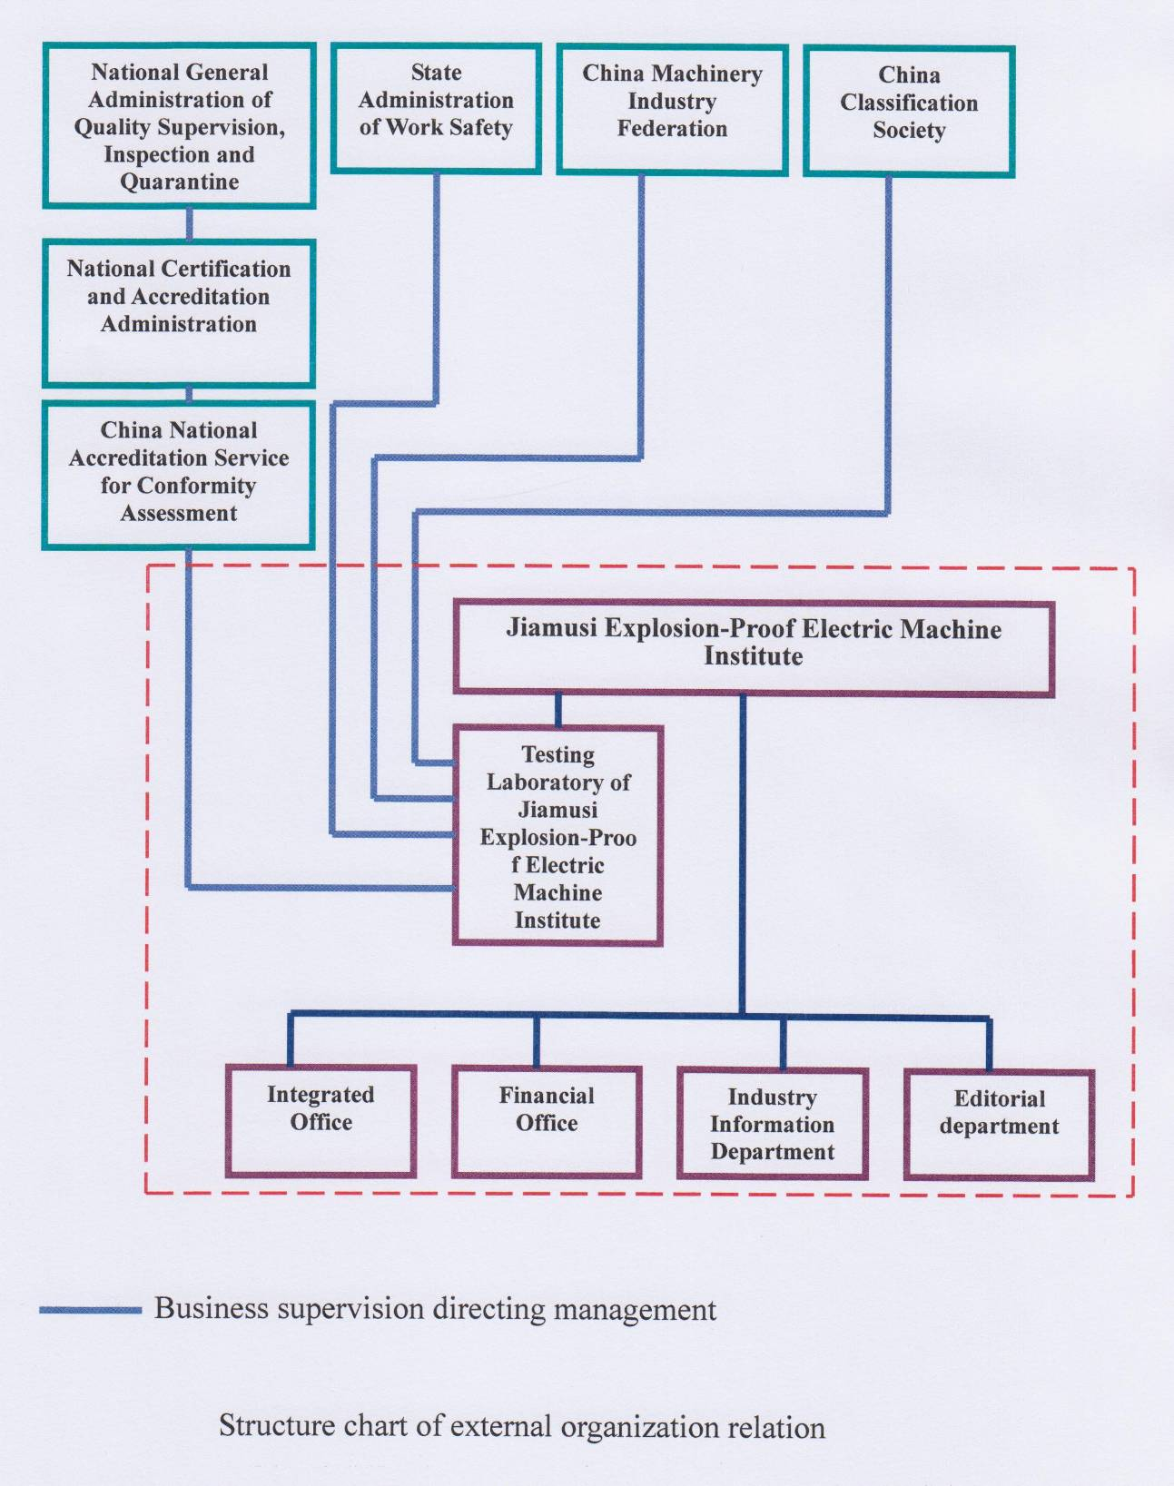

ANNEX 2: Organization Chart of the ExTL of CHEM

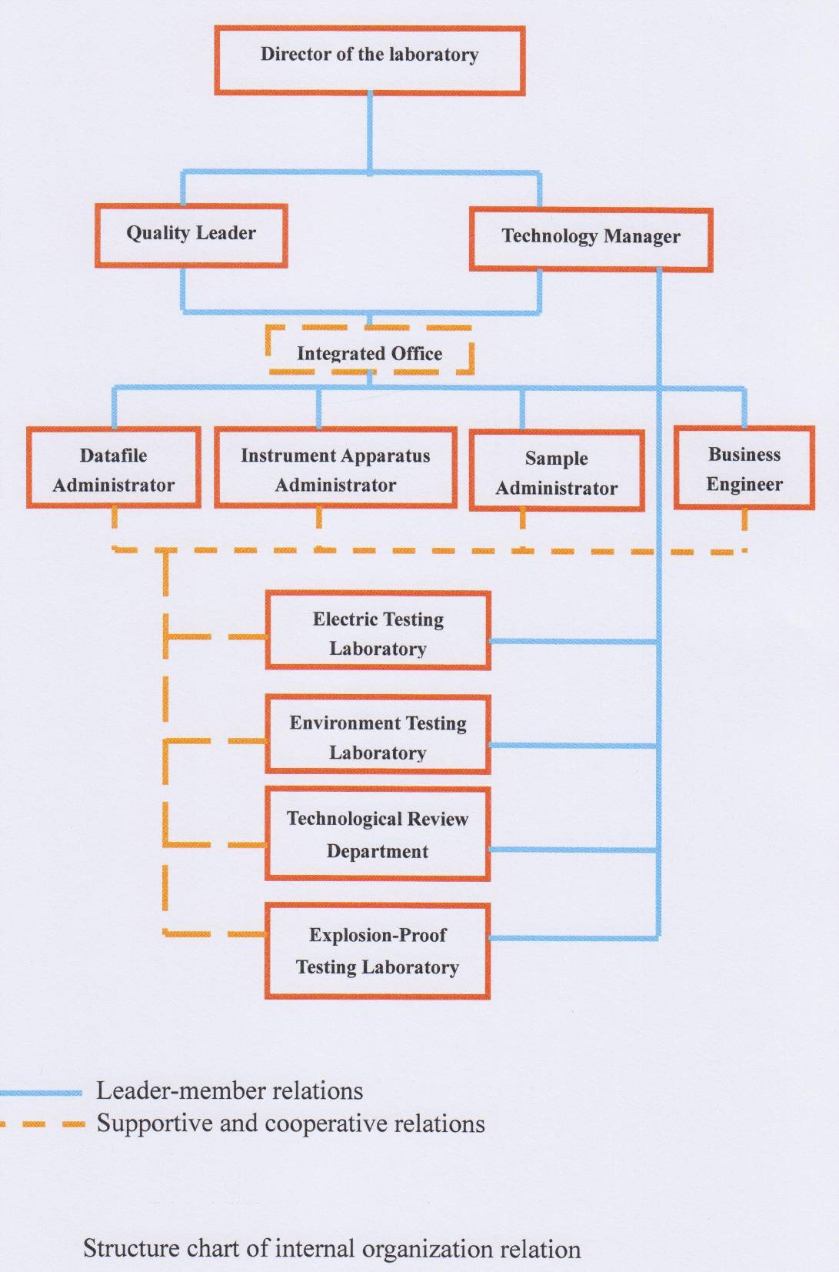
ANNEX 3: Organization Chart of Explosion-Proof Laboratory

Electric Testing Laboratory
Manager：Li Jigui ‘e’
Test engineer: Zhang Liyuan‘e’
Yin Fajun‘e’
Sun Lei‘e’

Environment Testing Laboratory
Manager: Song Zhifang ‘e’‘tD’‘t’
Test engineer: Li Hongyou ‘i’‘p’

Technological Review Department
Manager: Wang Fangli ‘d’‘e’‘p’‘i’‘tD’‘t’
Test engineer: Zhang Pingyi‘i’
Li Hongyou ‘i’‘p’
Liu Yongqin‘e’

Explosion-Proof Testing Laboratory
Manager: Yang Xichun‘d’ e’‘p’ ‘tD’‘t’
Test engineer: Guo Jiamin‘d’ e’‘p’ ‘tD’‘t’
Li Jiansheng‘d’ e’‘p’ ‘tD’‘t’

ANNEX 4: Accreditation Certificate according to ISO/IEC 17025

