COLLECTION OF IECEx / ExTAG DECISION
Standard:  IEC 60079-0 (Ed 7) | Clause:  7.3, 17.2.2 | Draft Decision Sheet:  ExTAG/698A/CD
Subject:  - Whether the non-metallic external fans of rotating electric machines are subjected to ultraviolet light resistance test  Status of document:  Approved | Key words:  - Resistance to ultraviolet light  - Materials for external fans | Date: 2023 07 28  Originator of proposal: CNEx  TC/SC involved: IEC/TC31 WG 22
Background

For Group II or Group III rotating electric machines, where not otherwise protected against exposure to UV light, a test of resistance of the material to ultraviolet light shall be carried out if the enclosure or parts of the enclosure, upon which the type of protection depends, are made of non-metallic materials.

The external fan impeller, fan hoods, and ventilation screens manufactured from non-metallic materials shall comply with Clause 7. A typical fan hood design that commonly used is shown as below:
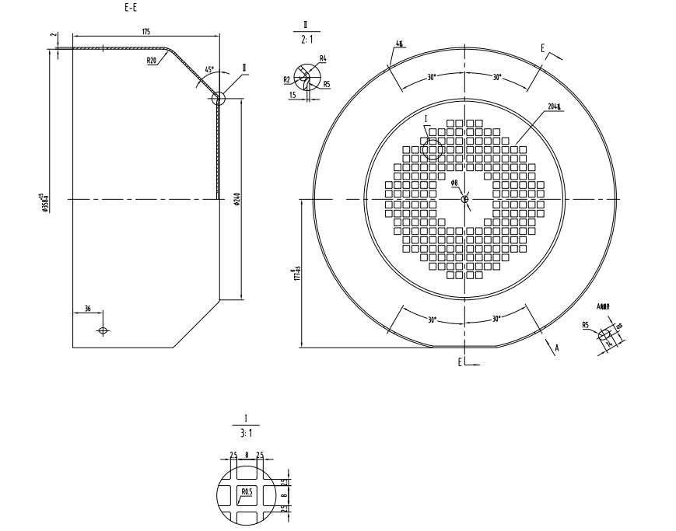

Question
For Group II or Group III rotating electric machines, is a fan made of non-metallic material and protected by the fan hood required to be subjected to the test for resistance to UV light?

Answer
For Group II or Group III rotating electric machines, clause 17.2.1 of IEC 60079-0:2017 stipulates that the degree of protection (IP) of the vent for rotating electric machines is at least IP20 at the air inlet and IP10 at the air outlet. The non-metallic external fan of the rotating electric machines is protected by a fan hood, and the mesh of the fan hoods meets the requirements of IP20. Generally, only the air inlet side could be potentially exposed to light(with the ingress of protection IP20 at worst). Therefore, the external fan will not directly exposed to ultraviolet light, and the test for resistance to UV light is not required.

