**INTERNATIONAL ELECTROTECHNICAL COMMISSION SCHEME FOR  
CERTIFICATION TO STANDARDS RELATING TO EQUIPMENT FOR USE  
IN EXPLOSIVE ATMOSPHERES (IECEx SYSTEM)**

**Title: Scope Assessment report for UL do Brasil Certificações, BR, to include Units Ex Ex 004 and Ex 006 in their scope as an Ex Certification Body (ExCB) for the IECEx 05 Certification of Personnel Competence Scheme (CoPC)**

**Introduction**

This document provides a Report from the IECEx Assessment Team following an assessment of UL do Brasil Certificações, BR, for a scope extension, as an IECEx Certification Body (ExCB) operating in the IECEx 05 CoPC Scheme, to include the following units in their scope.

Unit Ex 004 – Maintain equipment in explosive atmospheres

Unit Ex 006 – Test electrical installations in or associated with explosive atmospheres

The scope extension also provides for assessments to be conducted at the following additional location, but under the control of UL do Brasil.

Escola Senai  
Av. Senador Feijo 421  
11015-505 – Vila Matias – Santos – SP – Brasil

***This document is hereby submitted for ExMC approval via correspondence using the IECEx on-line voting system. ExMC Members are requested to submit their vote via the IECEx On-line Ballot System by the closing date 2020 11 02***

***Please refer to OD 050 for guidance on the “IECEx On-line voting system.”***

|  |  |
| --- | --- |
| **IECEx Secretariat**  **Australia Square Building  Level 33, 264 George Street**  **Sydney NSW 2000**  **Australia** | **Tel: +61 2 46284690**  **Fax: +61 2 4627 5285**  **Email: info@iecex.com** |

|  |  |
| --- | --- |
|  | ASSESSMENT REPORT |
|  |  |
| **BODY UNDER ASSESSMENT:** | **UL do Brasil Certificações** **Avenida Engenheiro Luis Carlos Berrini, 105 – 24 Andar 04571-010 – Brooklin – São Paulo** **Brasil** |
| **SITE(S)**  **ASSESSED:** | **UL do Brasil Certificações  Avenida Engenheiro Luis Carlos Berrini, 105 – 24 Andar 04571-010 – Brooklin – São Paulo Brasil** |

|  |  |
| --- | --- |
| **IECEx SITE RE-ASSESSMENT TEAM:** | **Thierry Houeix – Lead Assessor (FR – INERIS)** |
| **REPRESENTATIVE/S OF BODY:** | **Eduardo Galera** |
| **DATE(S) OF SITE RE-ASSESSMENT:** | **July-August 2020** |
| **SCOPE:** | **Current Scope = Units Ex000, Ex001, Ex003, Ex 007, and Ex008**  **Scope extension = Units Ex004, Ex006 and change of place of assessment** |

**IECEx 05 Certificate of Personal Competency Scheme**

**ASSESSMENT REPORT of**

**NEW IECEx APPLICANT BODY EXISTING IECEx CERTIFICATION BODY**

**X**

**(ExCB)**

Top of Form

|  |  |  |
| --- | --- | --- |
| **ASSESSMENT TYPE:** | **ATTACHMENTS** | **No. of Pages** |
| Application: | Application Form - UL do Brasil Certificações – UL is already accepted as ExCB for IECEx 05 scheme and Units Ex000 and Ex001, Ex003, Ex 007, and Ex008.  Extension for other units have been requested. The extension concerns: Units Ex004, Ex006 and change of place of assessment. | 4 |
| Surveillance: | Scope extension |  |
| Re-Assessment: |  |  |
| Other: |  |  |
| Assessment duration: | 1.5 days off-site during July-August 2020 |  |
|  |  |  |
| **RECOMMENDATION BY IECEx ASSESSOR(S)**  (Select one item only) | 🞎 That Acceptance be granted  🞎 That Acceptance be withheld/suspended  🞎 That Acceptance continues  🗹 That Acceptance be granted/continued conditional on Non Compliance/Matters raised, having agreed corrective action and time scales to rectify the System within and agreed time agreed by the Assessors | |

Bottom of Form

# SCOPE ASSESSED

UL do Brasil Certificações have been assessed according to the requirements of IECEx05 – Certification of Personnel Competencies [CoPC] for the following Units of Competency:

**Current Scope:**

Unit Ex 000 – Basic Knowledge

Unit Ex 001 – Apply basic principles of protection in explosive atmospheres

Unit Ex 003 – Install explosion-protected equipment and wiring systems

Unit Ex 007 – Perform visual and close inspection of electrical installations in or associated with explosive atmospheres

Unit Ex 008 – Perform detailed inspection of electrical installations in or associated with explosive atmospheres

**Scope extension being sought:**

Unit Ex 004 – Maintain equipment in explosive atmospheres

Unit Ex 005 – Overhaul and repair of explosion-protected equipment

Unit Ex 006 – Test electrical installations in or associated with explosive atmospheres

Unit Ex 009 – Design electrical installations in or associated with explosive atmospheres

Unit Ex 010 – Perform audit inspection of electrical installations in or associated with explosive atmospheres

**SECTION 1. GENERAL INFORMATION**

* 1. **Name of Body:**

UL do Brasil Certificações   
Avenida Engenheiro Luis Carlos Berrini, 105 – 24 Andar  
04571-010 – Brooklin – São Paulo  
Brasil

* 1. **CURRENT IECEx PARTICIPATION:**

UL do Brasil Certificações is an existing ExCB in IECEx System.

* 1. **DETAILS OF RE-ASSESSMENT TEAM:**

Thierry Houeix – Lead Assessor

* 1. **DATES OF ASSESSMENT:**

The off-site assessment was conducted during July-August 2020.

Many video chats have been made to achieve the assessment required for the scope extension.

* 1. **LOCATION OF ASSESSMENT:**

UL do Brasil Certificações  
Avenida Engenheiro Luis Carlos Berrini, 105 – 24 Andar  
04571-010 – Brooklin – São Paulo  
Brasil

* 1. **RESOURCES FOR IECEx 05 CERTIFICATION ACTIVITIES:**

The Assessment team have assessed and verified the availability of competent technical staff, support staff and facilities to undertake the full scope of IECEx 05 certification activities for extension of Units Ex004, Ex006 and also change of place of assessment. The place assessment can be also at UL do Brasil Certificações.

|  |  |  |
| --- | --- | --- |
| Place of assessment | Escola Senai Av. Senador Feijo 421 11015-505 – Vila Matias – Santos – SP – Brasil | UL do Brasil Avenida Engenheiro Luis Carlos Berrini, 105 – 24 Andar 04571-010 – Brooklin –  São Paulo – Brasil |
| Unit 3 | X | X |
| Unit 4 |  | X |
| Unit 6 |  | X |
| Unit 7 | X | X |
| Unit 8 | X | X |

At the conclusion of the assessment there were issues raised requiring attention by UL do Brasil Certificações . These issues have been included in the confidential report submitted and reviewed by the Secretariat. Follow up actions by UL do Brasil Certificações to address these issues was reviewed by the Assessor. All actions are satisfactory to enable all items raised to be closed and to recommend both on-going acceptance and acceptance of the scope extension

**SECTION 2. ASSESSMENT - SUMMARY OF RESULTS**

| **IECEx CoPC SCHEME REQUIREMENTS** | | | **Findings** | **COMMENTS AND REFERENCE TO ATTACHMENTS** |
| --- | --- | --- | --- | --- |
| **IECEx 05 requirements** | Confirmation of Scope of IECEx Acceptance or scope of application, (for new applicant) | | COMPLIES | The UL do Brasil Scope refers directly to the Scope of IECEx05 and has embraced all 4 of the Operational Documents. |
| Confirmation that details in original application are still current (for new application) | | COMPLIES | The details of this mid-term assessment were confirmed at the opening meeting. |
| Confirm currency and scope of accreditation (ISO/IEC 17024) applicable | | COMPLIES | UL do Brasil does not have accreditation to ISO/IEC 17024. Therefore this IECEx assessment includes assessment to ISO/IEC 17024. The subsequent assessment has verified compliance. This compliance is verified following assessment of UL LLC as the application for UL do Brasil depends entirely on compliance of UL LLC Systems. |
| Clause 9.1 | (a) in a participating country | COMPLIES | Brazil is a participating country in the IECEx System. |
| (b) operate recognized certification scheme | COMPLIES | UL do Brasil already participate in the IECEx Equipment Certification Scheme as an ExCB on both product and personnel schemes. |
| (c) competence demonstrated by assessment | COMPLIES | IECEx Assessment included technical reviews of UL do Brasil staff for competence to evaluate to OD 504 relevant to the Units of Competence Ex000, Ex001, Ex003, Ex007 and Ex008 |
| Assessment facilities considered by Assessment team to be appropriate and adequate for assessment of Units, according to OD 504? | | COMPLIES | The UL do Brasil Competence Procedures define the requirements for the knowledge skills assessment and examination including the procedures for conducting assessment and examinations. These were assessed by the assessment team and found to be satisfactory. See summary of results for OD504 for further detail. The procedures reviewed are identical to those of UL LLC except for the quotation procedure, this does not affect the process of Assessment and are therefore considered to comply with the requirements |
| Confirmation of which location is the official ExCB location, where more than 1 location is identified?  an official ExCB location is one where the following are conducted:   * applications received, * contract review (review of application) * assignment of application to ExCB staff * review of exam/assessments * decision to issue Certificate   (Contact IECEx Secretary for any questions) | | COMPLIES | UL do Brasil Avenida Engenheiro Luis Carlos Berrini, 105 – 24º Andar Brooklin – CEP 04571-010, Sao Paulo, SP Brasil |
| **ISO/IEC 17024 Assessment**–Satisfactorily Completed (for bodies without acceptable national Accreditation) | | | COMPLIES | As UL do Brasil does not have accreditation to ISO/IEC 17024, assessment to ISO/IEC 17024 was conducted as part of this assessment.  The assessment team confirmed that the UL do Brasil Quality Manual and associated Procedures, forms and Instructions comply with all aspects of ISO/IEC 17024 and IECEx requirements and these procedures are identical too and controlled by UL LLC. |

|  |  |  |  |
| --- | --- | --- | --- |
| **IECEx Operational Document**  **Requirements** | **OD 502** | COMPLIES |  |
| **OD 503** | COMPLIES |  |
| **OD 504**  (Review of ExCB assessment criteria including question bank, mapped against Competency Units of OD 504) | COMPLIES |  |

**Additional Remarks concerning requirements** (if any)

The correlation matrix of UL do Brasil is the following

|  |  |  |  |  |  |  |  |  |  |  |  |  |  |
| --- | --- | --- | --- | --- | --- | --- | --- | --- | --- | --- | --- | --- | --- |
| **Unit of Competence - Assessor** | | | | | | | | | | | | | |
| **Staff name** | **Invigilator** | **Ex 000** | **Ex 001** | **Ex 002** | **Ex 003** | **Ex 004** | **Ex 005** | **Ex 006** | **Ex 007** | **Ex 008** | **Ex 009** | **Ex 010** |
| A. Moreira | X | X | X |  | X | X | (*) | X | X | X |  |  |
| D. Dias | X | X | X |  | X | X | (*) | X | X | X |  |  |
| D. Miranda | X |  |  |  |  |  |  |  |  |  |  |  |
| E. Ribeiro | X | X | X |  | X | X | (*) | X | X | X |  |  |
| E. Galera | X | X | X |  |  |  |  |  |  |  |  |  |
| G. Carvalho | X | X | X |  | X | X | (*) | X | X | X |  |  |
| G. Castrillo | X | X | X |  | X | X | (*) | X | X | X |  |  |
| J. Bueno | X |  |  |  |  |  |  |  |  |  |  |  |
| L. Santos | X |  |  |  |  |  |  |  |  |  |  |  |
| (**) M. Machado | X | X | X |  | X | X |  |  | X | X |  |  |
| (**) F. Amaral | X | X | X |  | X | X |  |  | X | X |  |  |
|  |  |  |  |  |  |  |  |  |  |  |  |  |
| Observations: |  |  |  |  |  |  |  |  |  |  |  |  |
| (*) | For future qualification | | | | | | | | | | | |
| (**) | SENAI subcontractor | | | | | | | | | | | |

Organization Chart.

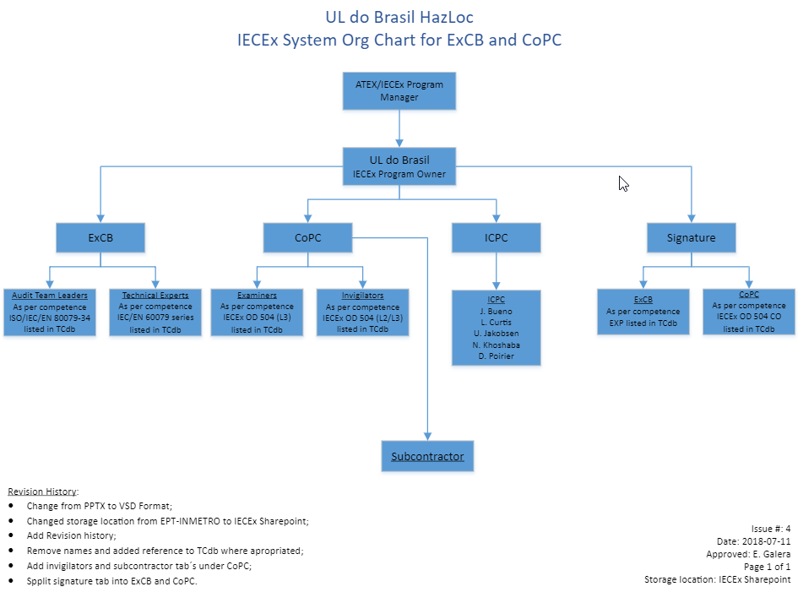

**Conclusion of Site Assessment**

The purpose of the site assessment was to verify compliance with the requirements of the IECEx Scheme for the initial acceptance of an Ex Certification Body (ExCB).

The site assessment forms part of the overall evaluation of the body by the IECEx Management Committee, ExMC and was conducted in accordance with the IECEx Scheme Assessment Procedures, IECEx OD 501.

Report of the on-site assessment team is as follows:

UL do Brasil has developed their own bay in order to perform the practical Ex evaluation

1. They prepared a document identified “Guidelines for IECEx 05 Practical Bays” which included the required items to perform a practical evaluation for Units Ex 003, Ex 004, Ex 006, Ex 007, and Ex 008
2. The Candidate Instructions for Units Ex 004 and Ex 006 have been reviewed
3. The Evaluation Sheets for Units Ex 004 and Ex 006 have been also reviewed
4. The bays used for the practical Ex evaluation for Units Ex 003, Ex 004, Ex 006, Ex 007, and Ex 008 have been checked using video chat

Observations

The observations was as follows:

1. It was requested to change de marking on the bay “Training Use Only” by something which say that these bays are only used for assessment according IECEx 05 and can’t be used for training!  
   UL do Brasil has decided to apply the marking “For assessment only” on the bay and on the documents relating to IECEx 05 assessments.

Target date for resolution of issues

All items raised have now been resolved and closed.

Actions after visit

No further visit has been required

Recommendation by IECEx Assessor(s) after all issues resolved

It is recommended for UL do Brasil Certificações for continued acceptance as ExCB regarding IECEx 05 and with the extensions of 2 Ex units in order to have the Units Ex000, Ex001, Ex003, Ex004, Ex006, Ex 007, and Ex008 in their scope.

In addition, UL do Brasil have their own Ex Evaluation bench in their facilities of Sao Paulo.