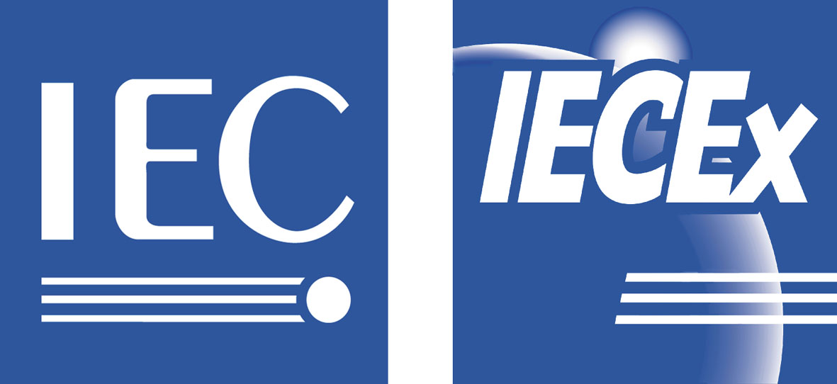 | ExMarkCo/30/DA  IECEx Mark Committee Meeting  16th June 2011, London  2011-05-19

INTERNATIONAL ELECTROTECHNICAL COMMISSION SCHEME FOR CERTIFICATION TO STANDARDS RELATING TO EQUIPMENT FOR USE IN EXPLOSIVE ATMOSPHERES (IECEx System)

IECEx Mark Committee MEETING

Draft Agenda IECEx Mark Committee meeting, to be held in Chiswick, London, UK, Thursday 16th June 2011
BSI Headquarters
389 Chiswick High Road,
London, WA 4AL,
United Kingdom

Expected Attendance

Tim Duffy ExMarkCo Chairman

IECEx Executive

Kerry McManama Chairman
Liu Weijun Vice Chairman
Chris Agius Secretary
Heinz Berger Treasurer
Ron Sinclair ExTAG Chairman
Michel Brenon ExTAG Secrtary
Uwe Klausmeyer Immediate Past Chairman
Wal Robson IECEx Secretariat
Members

(CN) Li Jiang
(DE) Siegfried Moesch
(FI) Risto Sulonen
(FR) Patrick Leroux
(GB) John Allen
(GB) Paul Beynon
(MY) Halim Hafiz
(NL) Theo Pijpker
(US) David Chirdon

SUBJECT | Discussion Leader
1 OPENING OF THE MEETING (Start 09:30)
Opening by the Chairman, self introduction of the participants, and noting of apologies for absence. | Chairman
2 APPROVAL OF THE AGENDA | Chairman
3 REPORT ON LAST MEETING  Document for Noting ExMarkCo/25/R  Also to note Actions Raised from Report | Secretary
- CONSTITUTION OF THE COMMITTEE  • Note the membership of the ExMarkCo and its terms of reference as per IECEx 01 Basic Rules  Document for Noting ExMarkCo/01E/inf  To also note the ExMarkCo dedicated webpage on the IECEx site at http://www.iecex.com/exmarkco.htm | Secretary
- NOTE ExCB APPLICATION PROCESS: members to Note  - ExCB applies to Secretariat to become IECEx Conformity Mark issuing body  - IECEx Staff reviews documentation for completeness  - ExMarkCo reviews application after staff approval and forwards (or rejects) to ExMC for formal approval  - ExMC formally votes on the application, ExCB & Central Office sign agreement | Chairman
- LIST OF CURRENTLY AUTHORISED ExCBs OD 001  on-line http://www.iecex.com/directory/bodies/OD001.asp (members area)  http://www.iecex.com/directory/bodies/bodies3.asp?id=5 (Public area)  Australia TestSafe, SIMTARS  Finland VTT  France LCIE, INERIS  Germany TUV SUD PS, PTB  Hungary BKI  Netherlands DEKRA  Norway NEMKO  United Kingdom Baseefa, ITS, SIRA  USA UL | Chairman
- LIST OF CANDIDATE ExCBs and STATUS  There are no Applicant ExCBs at present. | Secretary
- IECEx CONFORMITY MARK SCHEME DOCUMENTS FOR NOTING:  - IECEx 04 – IECEx Conformity Mark Licensing System  - OD/022/V1 – Rules and Procedures for the granting of Licenses to issue and use the IECEx Conformity Mark  - OD/023/V1 – Terms and Conditions for use of the IECEx Conformity Mark  - IECEx Guide – IECEx 04A – Guidance for making applications for an use of the IECEx Conformity Mark  - IECEx OD 011-4 Ed.1.2 - Guidance on Use of the IECEx Internet based “On-Line” Certificate of Conformity System (Part 4: Creating IECEx Conformity Mark Licenses)  Secretariat Note: Current regulations require that an ExCB may only issue an IECEx Mark License to cover IECEx Certificates that they themselves have issued and therefore maintain. This is seen by IEC Management as managing IEC exposure to risk. | Secretary
- USE OF IECEx LOGO  Documents for Consideration;  - ExMarkCo/29/CD Draft Use of IECEx Logo  - ExMarkCo/31/CC Comments on ExMarkCo/29/CD  Members are asked to consider Draft ExMC/29/CD in light of comments received for submission to the ExMC for approval. | Chairman / Secretary
- INQUIRY FROM PTB  - Letter from PTB (e-mail 8th March 2011) regarding manufacturers concerns about administrative workload and complexity with getting IECEx Mark License.  Documents for Consideration;  ExMarkCo/32/Inf – PTB Inquiry  Secretariat Note: To date while there may be a processing fee associated with the work by an ExCB when processing an application for an IECEx Mark License, payable by the applicant, there is no IECEx License fee nor application fee applicable to either the ExCB nor manufacturer, at Scheme level. This is now reflected under clause 4.1.3 of OD 19 Edition 7.0 | Chairman / Secretary
- CAB ISSUES CONCERNING MARK  To note CAB/929/R – IECEx Report to CAB issued to CAB October 2010. | Chairman / Secretary
- PROMOTIONAL ACTIVITIES:  To note the various promotional items listed under IECEx website “News Releases at http://www.iecex.com/news_releases.htm  Also to consider any other promotional aspects and opportunities. | Chairman / Secretary
- MISSUSE OF IECEx MARK AND LOGO – Report from Secretariat  - Follow up on any cases of misuse of IECEx mark or Logo | Chairman / Secretary
- OTHER BUSINESS | Chairman
- NEXT MEETING To consider the date and time for the next meeting, | Chairman
- CLOSE OF MEEETING | Chairman

