INTERNATIONAL ELECTROTECHNICAL COMMISSION (IEC) SYSTEM FOR CERTIFICATION TO STANDARDS RELATING TO EQUIPMENT FOR USE IN EXPLOSIVE ATMOSPHERES (IECEx SYSTEM)

TITLE: Draft ExTAG Decision Sheet – Reference pressure testing of devices with flame arrestors

Circulated to: ExTAG – IECEx Testing and Assessment Group

INTRODUCTION

This document, ExTAG/443/CD Draft ExTAG Decision Sheet – Reference pressure testing of devices with flame arrestors has been prepared by Intertek, US.

It is issued for a six week comment period for consideration by ExTAG Members.

Please submit comments using the comments table, a separate document by -

2016 12 23 to

Christine Kane

If there are no comments received the document will be forwarded for publication.

Julien Gauthier

Julien Gauthier
ExTAG Secretary

Address:  IECEx Secretariat  Level 33 Australia Square  264 George Street  Sydney NSW 2000  Australia  Web: www.iecex.com | ExTAG Secretary  Mr Julien Gauthier  LCIE S.A.  33 Avenue du General Leclerc  92260 Fontenay-aux-Roses  FRANCE  Tel: +33 1 40 95 55 26  Fax: +33 1 40 95 89 37  Email : julien.gauthier@fr.bureauveritas.com

COLLECTION OF IECEx / ExTAG DECISION
Standard:  IEC 60079-1:2014 Edition 7.0 | Clause:  15.4.2.2 | Date: 2016-10-31  Originator of proposal:  Intertek US
Subject:  Reference pressure testing of devices with flame arrestors | Key words:  - Breathers and Drains | TC/SC involved:  Draft Decision Sheet:
Background

15.4.2.2 For the determination of the explosion pressure in accordance with 15.2.2, breathing and draining devices shall be replaced by solid plugs.

Thermoelectric generators are gas-fired devices used to generate electricity for fixed industrial installations in off-grid, remote locations. When thermoelectric generators are used in hazardous locations (for example, offshore gas production platforms), it is desired that they provide protection by meeting the requirements of IEC 60079-1.

This is done by enclosing the thermoelectric generator in a flameproof enclosure as shown below in Figure 1. The items identified in red of the below Figure 1 are the flame arrestors elements needed for flame combustion.
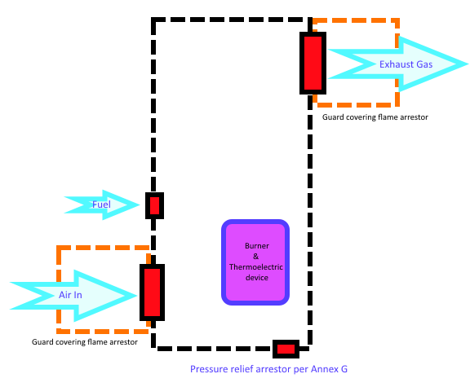
Figure 1 – Simplified equipment layout

Both of the larger flame arrestors (air intake and exhaust) are custom manufactured and are of the “crimped ribbon type” configuration per Annex A of IEC 60079-1. Each of these larger
arrestors is circular in shape with a diameter of approximately 140mm and a height of
around 20mm. Both the intake and exhaust crimp ribbons have an element of physical protection from external contact of debris with the arrestor face.

The product manual contains the following statement regarding inspection and maintenance of the flame arrestors: “Visually inspect flame arrestor components yearly or more frequently based on the installation site conditions and ensure that they are not restricted. If the flame arrestors are restricted, they must be cleaned or replaced.”

The flameproof enclosure housing the burner and thermoelectric device is constructed from aluminum castings according to the requirements of IEC 60079-1. A relatively large volume is used to allow exhaust gases and the exterior of the enclosure to cool enough to maintain a T3 temperature class. The volume of the flameproof enclosure containing the burner is around 40-50 litres.

The burner in the thermoelectric generator will stop operating if one or both of the air intake or exhaust flame arrestors is blocked. Given that the thermoelectric generator is the power source for the fixed installation, there will be an inherent indication to the equipment operator of a fault condition and the need to immediately address the flame arrestor blockage.

Question

To what extent should these flame arrestors be plugged for carrying out the reference pressure test?
Due to the nature of this assembly and use of multiple flame arrestors plugging all four flame arrestors for determination of reference pressure seems over onerous for a Zone 1 standard. Also designing a product to meet such a requirement would result in an excessively heavy enclosure.

Proposed Answer

A single fault condition would normally be applied to Zone 1 equipment (blocking of one arrestor), reference pressure testing could be carried out with one arrestor plugged at a time. However, it has been proposed to subject the equipment to reference pressure testing with all flame arrestors plugged to 75% during the test .The requirements of ISO 16852 have also been considered.

