INTERNATIONAL ELECTROTECHNICAL COMMISSION (IEC) SYSTEM FOR CERTIFICATION TO STANDARDS RELATING TO EQUIPMENT FOR USE IN EXPLOSIVE ATMOSPHERES (IECEx SYSTEM)

TITLE: Draft ExTAG Decision Sheet – Guidance on issuance of QARs when products are manufactured at multiple sites

Circulated to: ExTAG – IECEx Testing and Assessment Group

INTRODUCTION

This document, ExTAG/445/CD Draft ExTAG Decision Sheet – Guidance on issuance of QARs when products are manufactured at multiple sites, has been prepared by ExMC WG01

It is issued for a six week comment period for consideration by ExTAG Members.

Please submit comments using the comments table, a separate document by -

2017 01 10 to

Christine Kane

If there are no comments received the document will be forwarded for publication.

Julien Gauthier

Julien Gauthier
ExTAG Secretary

Address:  IECEx Secretariat  Level 33 Australia Square  264 George Street  Sydney NSW 2000  Australia  Web: www.iecex.com | ExTAG Secretary  Mr Julien Gauthier  LCIE S.A.  33 Avenue du General Leclerc  92260 Fontenay-aux-Roses  FRANCE  Tel: +33 1 40 95 55 26  Fax: +33 1 40 95 89 37  Email : julien.gauthier@fr.bureauveritas.com

COLLECTION OF IECEx / ExTAG DECISIONS

Standard:  N/A | Clauses:  N/A
Subject: Guidance on issuance of QARs when products are manufactured at multiple sites  Status of document: Draft | Key words:  - QAR  - Manufacturing Location | Date: November 2016  Originator of proposal: ExMC WG01

Background:

ExCBs are employing different methods when issuing QARs to Manufacturers with worldwide operations, i.e. products are being produced in multiple facilities around the globe. Some ExCBs require that each site audited receive a separate QAR. Other ExCBs are including multiple sites within the same QAR.

Each approach has advantages and disadvantages. An advantage of issuing a separate QAR for each site audited is that the overall QAR will not be suspended due to a problem or delay at any one site. A disadvantage of this approach is that multiple QARs must be linked to each CoC, introducing the possibility of errors or creating confusion among CBs.

QUESTION: Do the IECEx Rules or Operational Documents require a separate QAR to be issued for each site audited?

ANSWER: No, the rules and ODs leave this up to the discretion of the issuing ExCB. Recognizing that this may lead to different approaches among ExCBs, the following guidance is provided to assist with various situations an ExCB may encounter:

- When a manufacturer controls multiple manufacturing locations under the same quality management system, the manufacturer may prefer that one QAR is issued to cover all locations. See Examples 1 and 2 below, for two acceptable methods of indicating this arrangement on the online QAR registration. If different sites contain different protection methods within their scope, then the format in example 1 should be used.
- When a product is manufactured at multiple manufacturing locations that are not under the same quality management system, it is recommended that a separate QAR be issued due to the differences that may exist between locations. However, the ExCB may decide to issue a single QAR as shown in examples 1 and 2.
- When some manufacturing locations hold certification to ISO 9001 and other locations do not, then separate QARs should be issued, due to the different audit frequencies.

In all cases, the ExCB and manufacturer shall work together to ensure that audit(s) at each site(s) support timely completion. The ExCB and manufacturer shall consider the time required for a manufacturer’s response to audit findings and acceptance by the ExCB, when scheduling the audit.

It should also be noted that the Rules, IECEx02, distinguish between a Manufacturer, Manufacturing Location, Production Site, and Supplier. Suppliers are not required to be audited by the ExCB if the manufacturer’s quality system complies with the requirements in 7.4 of ISO/IEC 80079-34:2011.

QAR Example 1:
Include details in the “Comments” field:
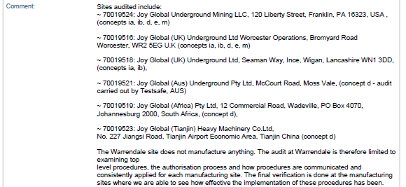

QAR Example 2:
List all sites audited in the “Site(s) audited” field.
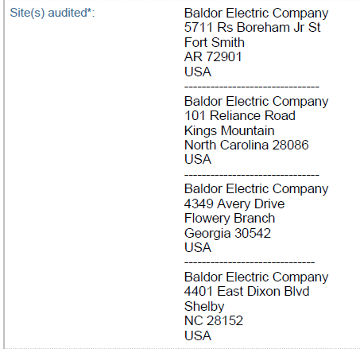

Example of text to be entered on the CoC, in the “Additional Manufacturing Locations” field:
“These products may be manufactured at any [Manufacturer’s Name] facility that has been audited for the manufacture of the type of protection defined on this certificate. In addition, the site must also be listed on the linked Quality Assessment Report [QAR number] or its subsequent issues.”

